ABLEKUMA CENTRAL MUNICIPAL ASSEMBLY
ENVIRONMENTAL HEALTH AND SANITATION UNIT
REPORT ON PAUPER AND IT’S CONVEYANCE TO THE POLICE HOSPITAL MORGUE ON THURSDAY 22ND JUNE, 2023.
On Thursday 22nd June, 2023, a report was made by the Chief Executive of Ablekuma central Municipal Assembly about a pauper lying at Old Fadama beside the old fadama clinic (former onion market).
A team of Environmental health officers led by the Municipal Environmental Health Officers (MEHO) visited the site to authenticate the complaint. The police commander at Agbogbloshie was notified and supported us with two (2) police officers.
The Environmental Health Officers disinfected the site and the mortal remain which was semi- decompose. The pauper was shrouded and put in a body bag and transported to the police morgue with the support of the two (2) police officers.
Below are some pictures depicting the incident:

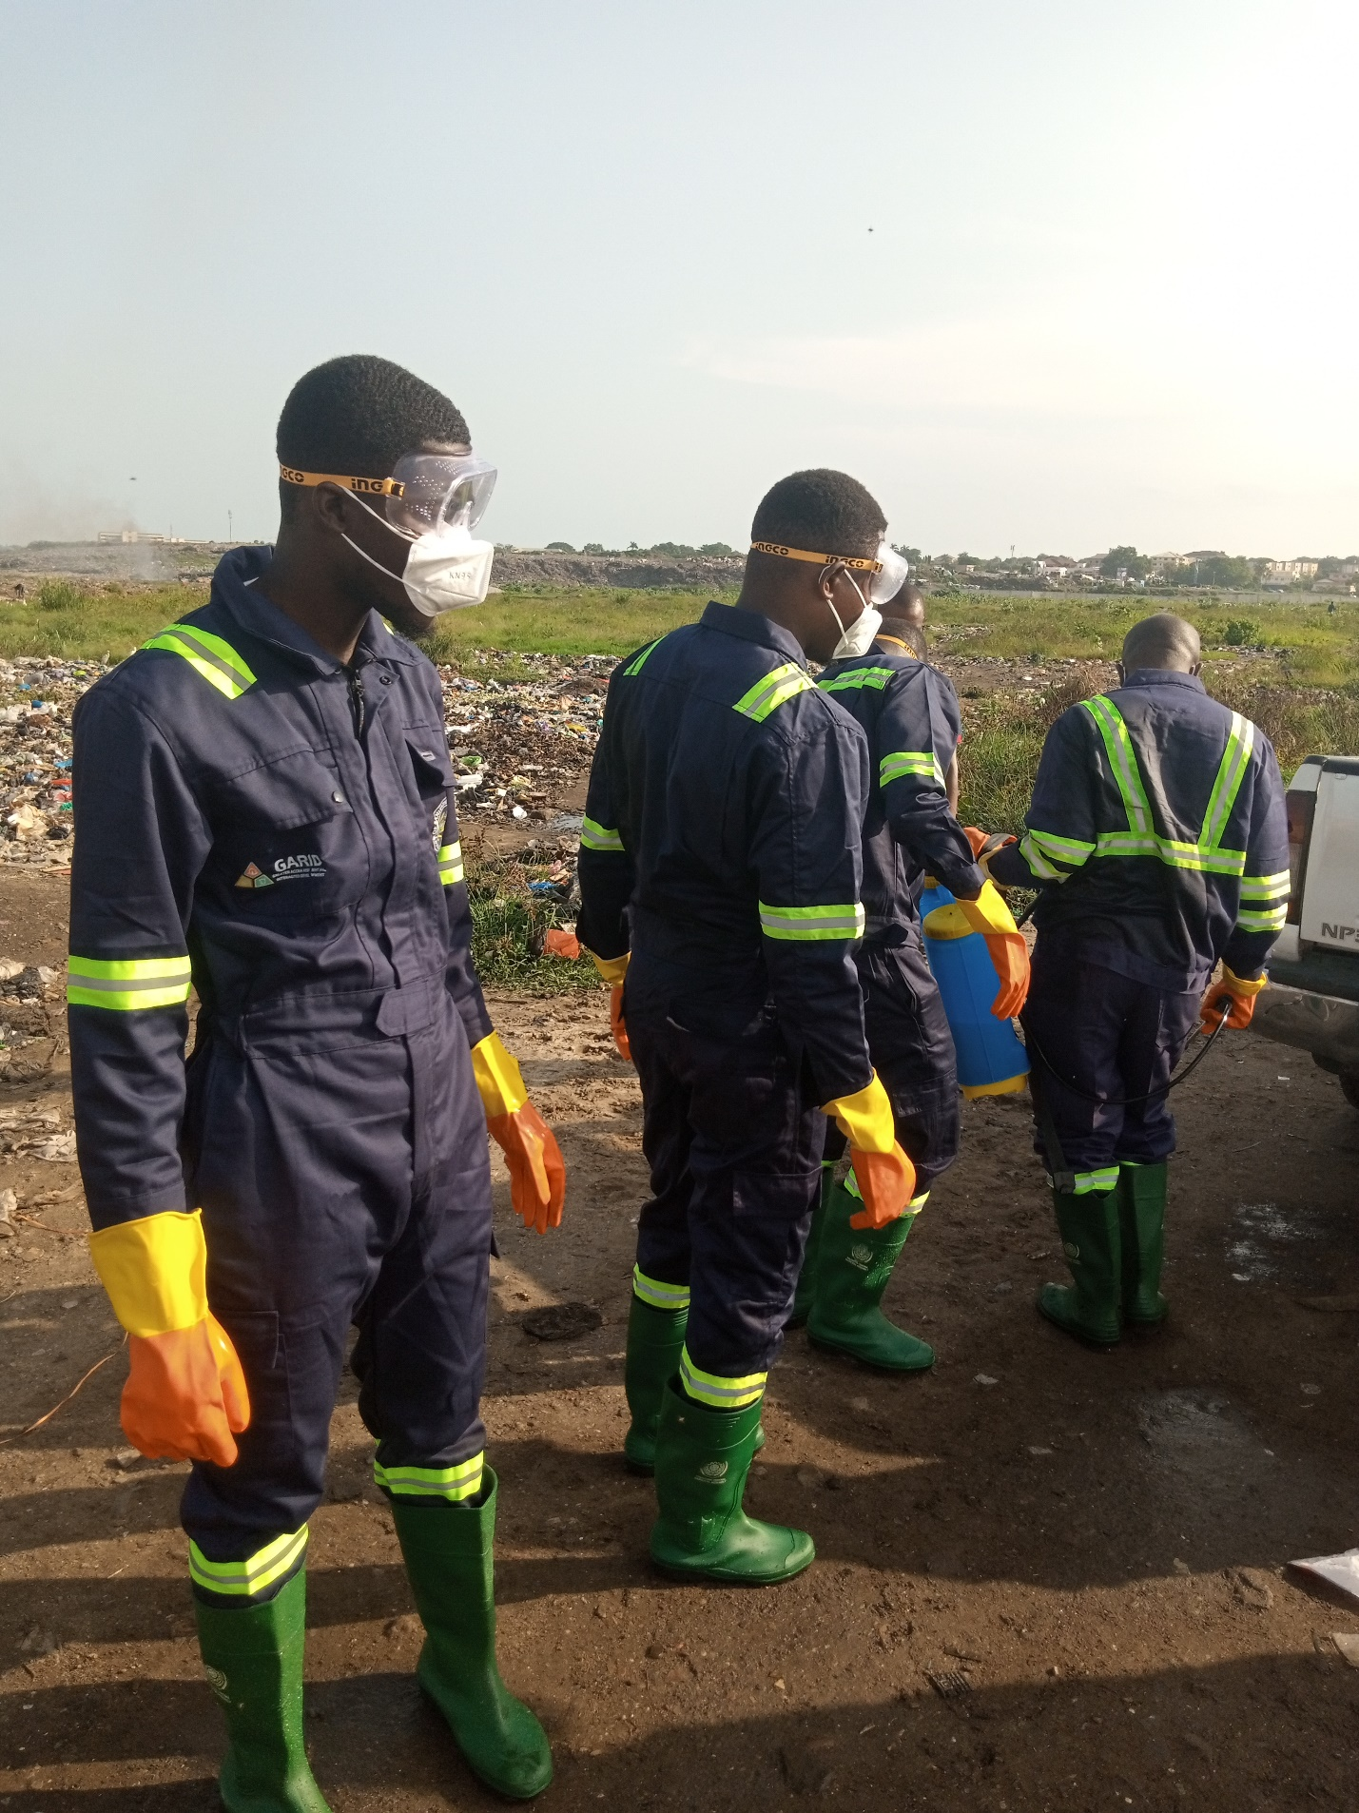
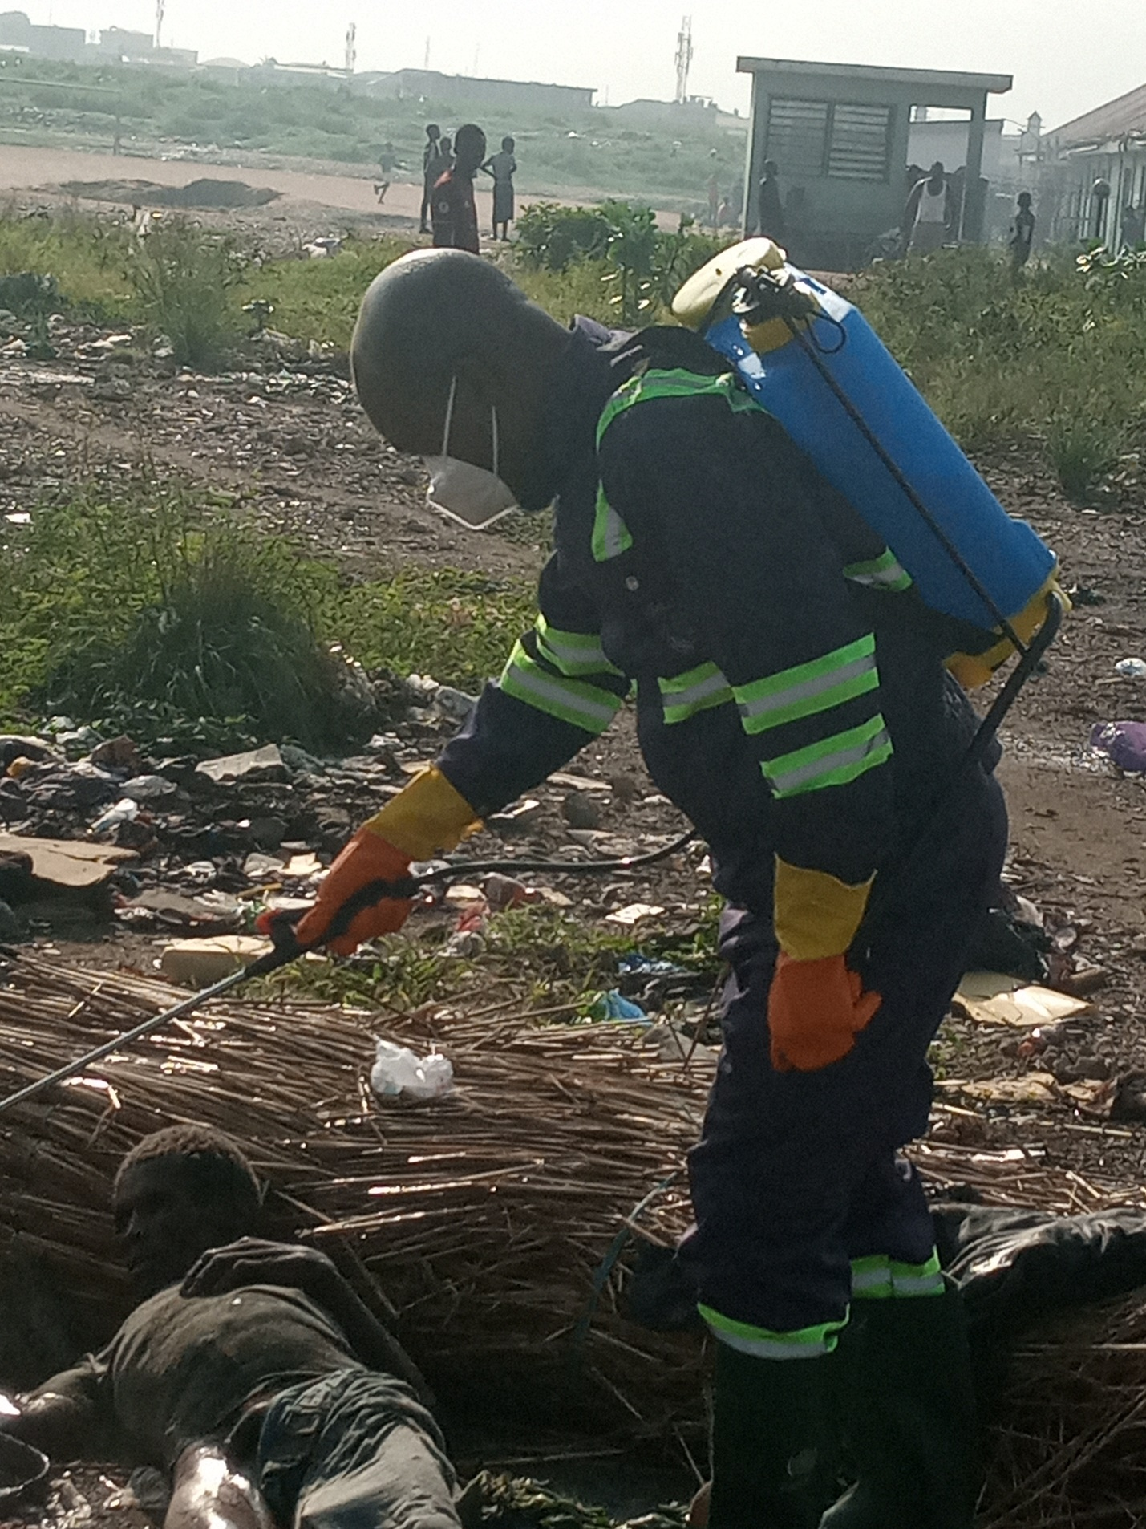
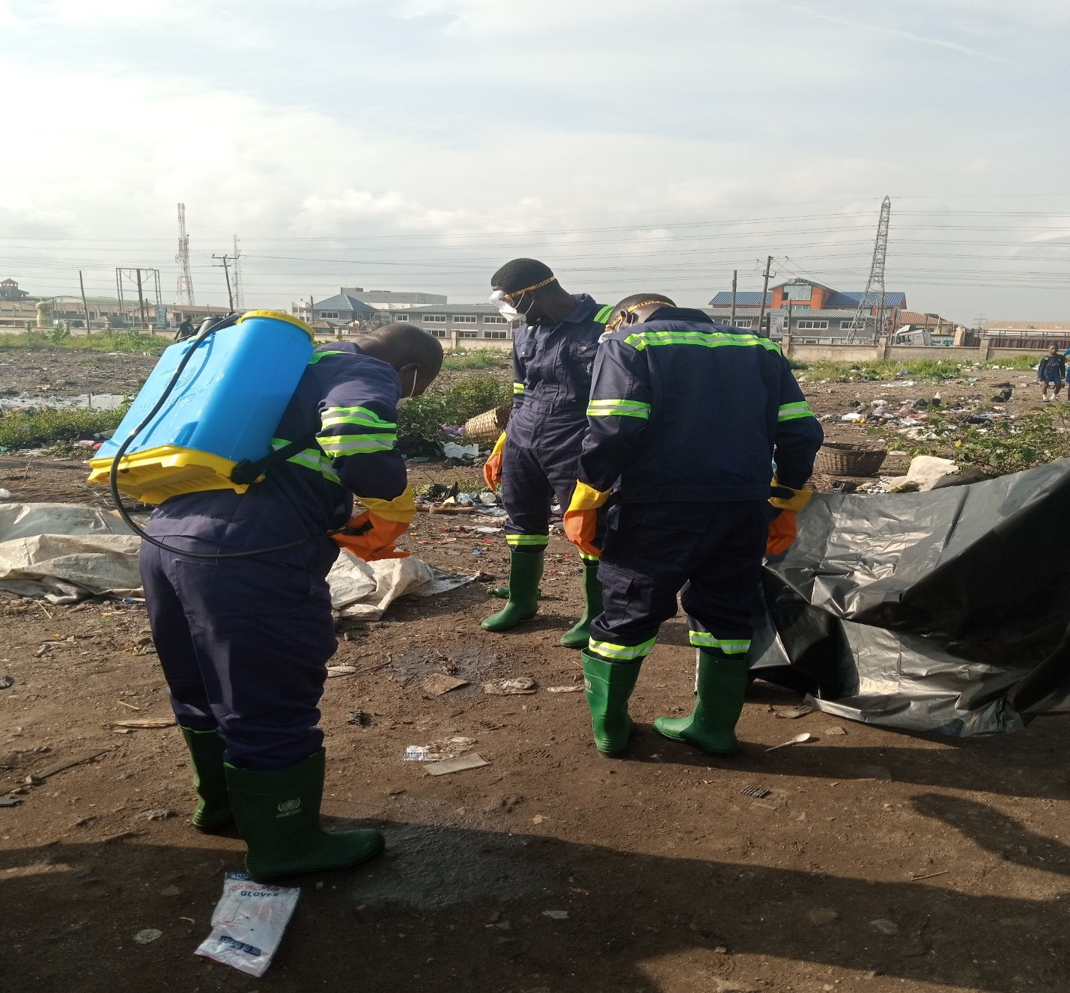

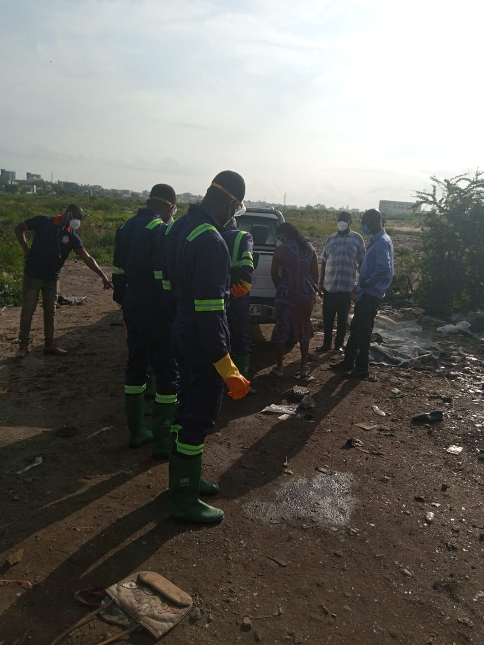

BRIDGET SEYRAM DIAPIM
MUN ENV’TAL HEALTH OFFICER

